Car Accident Severity Classification

Mohammad Refi Nur Ghozi

October 10, 2020

# Introduction

Problem Description. where you discuss the business problem and who would be interested in this project.

This project will try to predict crime in manhattan on january 2020 using naive bayes. naive bayes technique blabla

# Data Description

nyu-geojson data to retrieve the neighborhood latitude and longitude

foursquare api to retrieve the venues latitude and longitude []

NYPD complaint data with a year range from 2015 – 2019 []

# Methodology

First i load the nyu geojson data to get neighborhood’s longitude and latitude. I only use the manhattan borough.

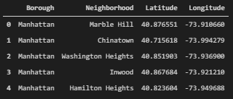

Then i can make a folium map of manhattan using the coordinates.

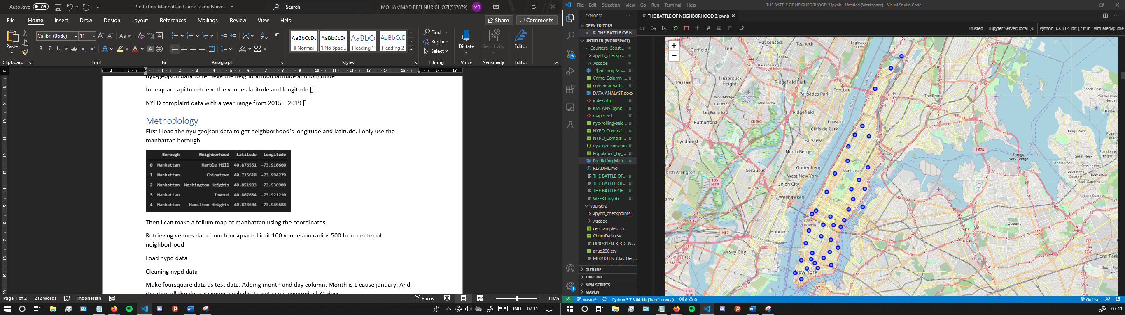

Retrieving venues data from foursquare. Limit 100 venues on radius 500 from center of neighborhood

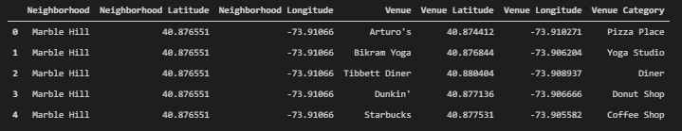

Make foursquare data as test data. Adding month and day column. Month is 1 cause january. And iterating all the data assigning each day to data so it covered all 31 days.

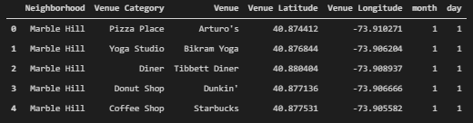

Final

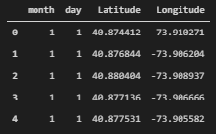

Load nypd data. Nypd data have a lot of column, you can see them here. So we gonna use only this.

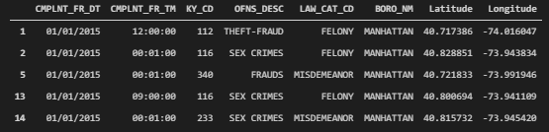

Only felony

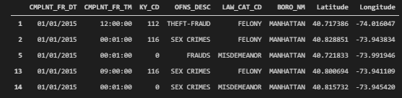

Getting datetime format from complaint exact date of occurence

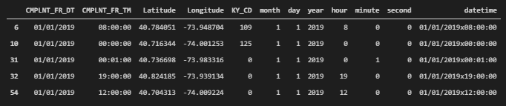

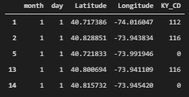

Training nypd data + cv

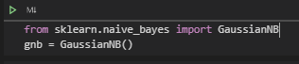

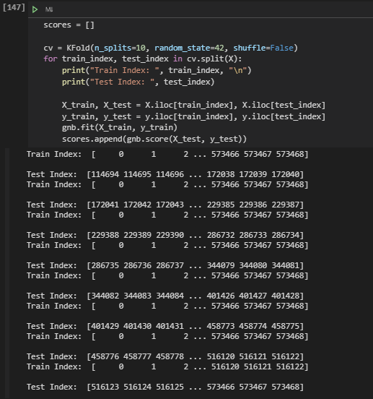

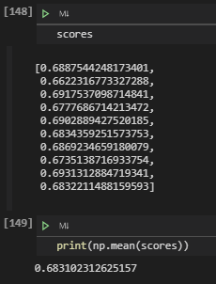

Predicting nypd data with test data earlier and getting result

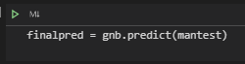

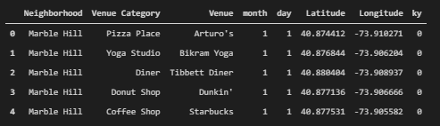

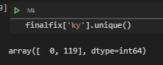

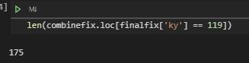

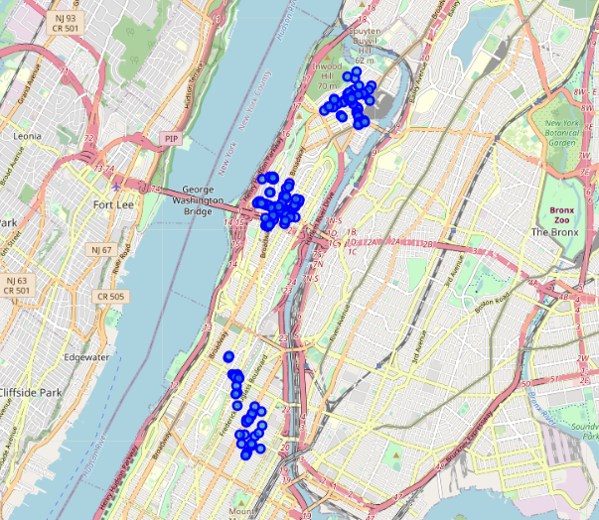

# Results

section where you discuss the results.

# Discussion

section where you discuss any observations you noted and any recommendations you can make based on the results.

# Conclusion

section where you conclude the report.

Footnote

https://geo.nyu.edu/catalog/nyu_2451_34572

https://developer.foursquare.com/

https://data.cityofnewyork.us/Public-Safety/NYPD-Complaint-Data-Historic/qgea-i56i